The literature landscape on 1.5°C Climate Change and Cities

*William Lamb1, Max Callaghan1, Felix Creutzig1,2, Radhika Khosla3, Jan Minx1,4*

*Affiliations*

*1 Mercator Research Institute on Global Commons and Climate Change, Torgauer Str. 14, 10829 Berlin, Germany*

*2 Sustainability Economics of Human Settlements, Technical University Berlin, Str. des 17. Juni 135, 10623 Berlin, Germany*

*3 Centre for Policy Research, New Delhi 110021, India*

*4 Hertie School of Governance, Friedrichstr. 189, 10117 Berlin, Germany*

*\* Corresponding author: [lamb@mcc-berlin.net](mailto:lamb@mcc-berlin.net)*

*Abstract. Cities are key for achieving the 1.5°C warming limit of the Paris Agreement. However, synthesizing policy insights from the urban literature is a challenge, due to its rapid growth, breadth of topics, and relative lack of assessments so far. Here we introduce methods from computational linguistics to build a systematic overview of research on transport, buildings, waste management, and urban form. We find that the epistemic core of the mitigation-focused urban literature is currently centered on urban form and emissions accounting, while extensive research into demand-side options remain overlooked, including congestion and parking polices, active travel, and waste management. In the IPCC Special Report on 1.5°C, and for meeting the target itself, all such city-scale opportunities need to be examined.*

# Introduction

The Intergovernmental Panel on Climate Change (IPCC) has been tasked with a Special Report (SR) to comprehensively assess the state of scientific knowledge on the 1.5°C warming limit laid out in the Paris Agreement. The discussion on the 1.5°C limit so far has focused on negative emissions and the higher economic costs for staying within tight and fast dwindling emission budgets [1–4]. Less discussed is the role of cities, which have both direct leverage over energy consuming behaviors and infrastructures, and the potential for drastically increasing near-term mitigation ambition.

The available evidence on the 1.5°C warming limit suggests that viable mitigation pathways must combine the most difficult features known from 2°C scenarios to achieve faster and even deeper emissions reductions: immediate political action, development along very low energy demand pathways, the availability of all major mitigation technologies, and sustained periods of net negative emissions across the second half of the 21st century [3,5]. Such ambition levels can only be achieved if all available mitigation options are reaped at all governance levels – from the global to the local. Cities are hotspots of human activities and infrastructures. They have direct leverage over end-use energy consumption in transport systems, buildings, and other sectors, and therefore play a central role in limiting warming to 1.5°C [6–9].

Cities are also emerging as one of the more ambitious policy communities in global climate change governance, even as national progress continues to lag. A number of initiatives have pledged substantial emission reductions, such as the C40 [10] and the Global Covenant of Mayors [11]. Such actions could prove decisive for ratcheting up the currently inadequate short-term mitigation ambitions expressed in the nationally determined contributions [12,13]. Cities and local governments are thereby increasingly recognized as important building blocks for organizing ambitious climate policies in a multi-level governance system [9,14,15].

The assessment of an urban mitigation literature, however, faces two fundamental challenges: first, like in other fields of climate change research, the body of relevant literature is large and fast-growing. Minx et al. [16] estimate that the quantity of new peer-reviewed research (as recorded by the ISI Web of Science) published during the sixth IPCC assessment cycle is roughly equal to the size of the entire climate change literature before AR6. The task of systematically tracking scientific progress in assessments is therefore increasingly difficult to manage, even in highly specialized fields. To avoid bias and systematic omissions, it will be important to identify and select literature in a transparent fashion, although such procedures are currently lacking in the IPCC. Second, despite recent progress [17], urban climate change assessments are still in their infancy. The available literature has not yet been aggregated into discrete bodies of knowledge that can be easily drawn upon. Not least, we still lack a basic understanding of the urban contribution to global emissions and the drivers thereof [15,18–20].

To enable a more robust and transparent assessment of the role of cities in climate change mitigation, and to advance discussions in urban climate change research, the relevant literature base needs to be characterized to answer a few questions: How is the literature organized in terms of key objectives and/or policies for the short, medium and long-term? What are the core topic areas in the literature that currently emphasize urban climate change mitigation? What are the epistemic communities that drive this growing urban literature? Finally, what methods can be drawn upon to assist in the synthesis of urban literatures?

As a first step towards addressing these issues, this paper systematically identifies the relevant literature on cities and climate change based on methods from computational linguistics. The state of the research field in terms of its thematic structure is analyzed to inform the upcoming special report on the 1.5°C goal. We build a reproducible search query based on our understanding of the urban literature, focusing on urban mitigation measures and policies related to transport, buildings, waste, and urban form. We use automated content analysis to gain an overview of the topics and themes in this literature, and bibliometric analysis to identify epistemic communities in the field. Finally, we deploy these methods to examine the IPCC 5th Assessment (AR5) Working Group III (WGIII) report in terms of its coverage of urban mitigation issues, highlighting current gaps that the upcoming SR could fill.

# Methods

## Delineating the urban mitigation literature

Our starting point in this study is to outline and justify the broad topics, policies and objectives that an urban mitigation assessment should focus on. In our view, the focal point of an urban mitigation assessment should be on the demand-side of urban energy consumption and its associated climate impact, as not only are the everyday practices and uses of energy highly influenced by the shape, structure and organization of cities [21–23], but the majority of energy consumption in the 21st century is projected to take place within them [15,24–26]. Although supply-side activities such as power generation and industry also take place within cities, they are already well captured by other research communities (in particular, integrated assessment modelling). By contrast, the demand-side of climate change mitigation, including both consumer end-use and preference-shaping infrastructures, has received less attention in climate assessments (but see [27]).

Four key domains of literature can shed light on the urban drivers of greenhouse gas emissions, and opportunities for their mitigation: transportation; buildings; waste management; and urban form (Figure 2). These domains correspond to the emissions generated in cities from direct energy use and, in our judgement, are the most accessible for urban policymakers [5]. Although the lifestyles, end-user demand patterns, and infrastructures covered by these domains are hardly independent of supply-side issues, we aim to exclude the latter where they are not specific for cities or city-level policies. For instance, literature on industry is excluded as this sector is increasingly located outside urban areas, and is best regulated by national or state agencies via economy-wide policies. Although supply-side waste management also tends to be located close to or outside city boundaries, we do include it here, as demand-side aspects are of high importance.

In the context of the 1.5°C target, these domains play varied roles along different timescales. Understanding these time scales is crucial for advancing urban contributions towards net zero emission trajectories.

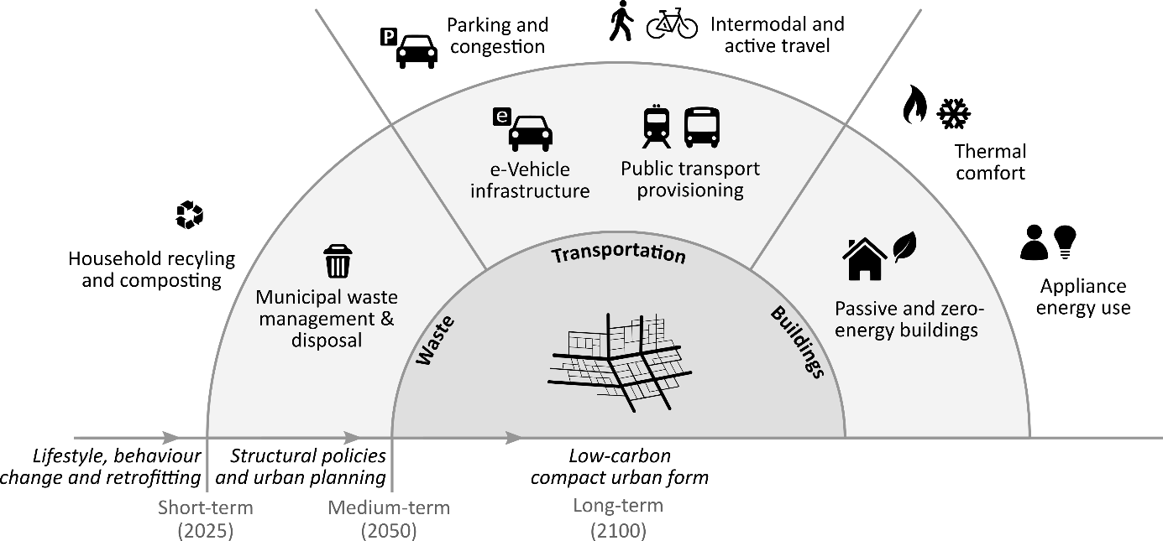

**Figure 2: Scope and time-scales of the urban mitigation literature assessed, including measures that address urban transport, buildings, waste, and urban form.** Note that neither supply-side energy production and industry, nor a broader set of provisioning infrastructures and services (e.g. healthcare access, green spaces) are captured in the scope. We do not included these as the former is assessed in other mitigation communities, and the latter is more appropriate for an assessment of sustainability, rather than climate change mitigation.

In the short-term (present-2025), lifestyle and behavioral options can contribute the most to climate change mitigation. This involves changes in preferences, habits, and decision-making, such as telecommuting, adapting to different room temperatures, food waste reduction, and so forth. These have been reviewed in literatures on the urban transport sector [23,28–31], the building sector [32–35], food waste [36], and the overall demand-side [27].

The middle- (2025-2050) and long-term (to 2100) is dominated by capital and infrastructure stocks [37]. Many options are situated in the buildings sector, including more efficient consumer appliances, heating and cooling systems, and building envelope design and materials. However, they must be fostered now to achieve notable results starting in 5-10 years. Similarly, the long life-time of road and rail-based systems (40-75+ years) means that the transition towards sustainable transport systems must be implemented now to enable deep decarbonization pathways within 20-40 years – making them immediate term decisions with long term implications.

With the efficient use of buildings and city space, underpinned by active travel and public transportation, important network externalities emerge, driving cities towards low-carbon compact urban forms towards the end of this century. Thus the “urban form” domain captures aspects of both transport and buildings, and emerges from specific transport and building interventions, but is distinct in addressing layout and wider systemic effect at larger spatial scales. Urban form also emphasizes the close entanglement of the transport and building systems, for instance through fuel prices, which shape street layouts, building heights and floor spaces, and the balance of different transport systems [38–40].

## Literature search, automated content analysis and scientometric analysis

To identify the urban mitigation literature covered by these four domains, we develop a structured search query for the Web of Science (WOS) literature database. This includes specific combinations of keywords for each domain (e.g. “bicycle infrastructure provisioning”), as well as more generic strings (“low-carbon transport”). We aim to identify mitigation-relevant studies as well as mitigation-focused studies (i.e. papers on urban congestion policies that do not directly refer to emissions reductions would be included). The full search methodology is detailed in the Supplementary Materials (SM). Using the search query we acquire a document set. This is largely comprised of journal papers, but also includes conference proceedings and book chapters. For each document, we obtain the title, abstract, keywords and list of references.

To digest the major themes of the document set, we perform: (1) an automated content analysis on the document titles, abstracts and keywords; and (2) a scientometric analysis on the document references. For (1) we use non-negative matrix factorization [41], a method that assumes words systematically co-occur within documents, and that repeated co-occurrences across the document set indicate a shared semantic structure (“topics”). This procedure will generate a list of topics for the entire document set, where each topic is comprised of co-occurring words (e.g. the words “air”, “pollution”, “quality” likely describe a topic focused on local air pollution). Since our search query already specifies the content of research in our document set, this method may appear redundant. However it offers important advantages: it provides quantitative metrics describing the prevalence of each topic; it allows us to examine the correlations between topics (based on the likelihood that they appear together in documents); and it will discover latent topics alongside those we explicitly searched for.

For (2), we use the reference data from our document set to generate a bibliographic coupling network (two documents are “coupled” if they cite the same third document). The bibliographic coupling network is clustered using a community detection algorithm, identifying groups of documents that tend to cite similar literatures. Combining these results with the automated content analysis, we then describe the topics of research that are prevalent within each cluster, thereby exposing epistemic communities within urban climate change research.

Finally, we compile a list of references from the IPCC AR5 WGIII Report, allowing us to examine its direct coverage of the urban literature and topics we identify in the preceding analysis. Refer to the SM for a full description of these methods.

# Results

Our urban mitigation search query identifies a substantial (9,525 publications) and fast growing literature (20.5% per year; see Supplementary Materials Figure 1). The IPCC AR5 has directly cited 129 of these documents. While this raises questions with regard to transparent literature selection in the IPCC, tWGIII, specified in our query Moreover, more than 3500 studies have appeared since AR5 (2014 onwards) and have therefore not been assessed by the IPCC directly or indirectly. Future assessments therefore face a significant task in covering the full breadth of relevant work. In the following sections we present the major themes of the urban literature we identify (the automated content analysis), and the epistemic communities within this field (scientometric analysis).

## Major themes in urban mitigation research

The automated content analysis identifies 27 topics across the document set (table 1). These include subject areas that were explicitly specified in our search (e.g. “active travel” and “urban form”), as well as latent topics discovered by the analysis (e.g. “network optimization”, “travel behavior”, “air quality”). There are many topics related to transportation research (#2, #9, #10, #12, #14, #16, #20, #21, #22, #24, #25, #27), fewer on buildings (#4, #5, #13, #19, #26), only 3 on waste (#8, #15, #23), and a single topic on urban form (#6). In the automated content analysis a paper may contain multiple topics; some topics therefore represent more general discourses that appear across multiple areas of research. For instance, the most prevalent topic is “planning & governance”, a policy-oriented discourse that can be found in approximately 10% of the literature we identify.

A range of competing discourses and priorities are apparent across the literature. The keywords listed in building energy standards (#5) show a consistent theme of energy performance assessment in relation to national building standards and codes (the documents highly correlated with this topic discuss the LEED certification and similar schemes). Energy efficiency & consumption (#4) and thermal comfort (#13) capture technical aspects of energy use in buildings (e.g. appliance efficiency), as well as their interface with human behavior (e.g. thermostat preferences). Within transportation research, congestion charging (#10) is clearly oriented towards traffic management; the public transportation modes (#9, #16) emphasize access and ridership levels; while active travel (#2) remains very much grounded in a public health discourse.

|  |  |  |  |  |
| --- | --- | --- | --- | --- |
| **ID** | **Topic Name** | **Stemmed Keywords** | **Marginal Topic Distribution (%)** | |
| 1 | Planning & governance | develop, sustain, govern, polici, project | | 9.7 |
| 2 | Active travel | activ, health, household, school, walk | | 6.5 |
| 3 | Network optimisation | model, network, optim, propos, problem | | 6.2 |
| 4 | Energy efficiency & consumption | energi, effici, consumpt, save, household | | 6.0 |
| 5 | Building energy standards | build, energi, perform, green, design | | 5.0 |
| 6 | Urban form | urban, citi, land, area, green | | 4.5 |
| 7 | GHG emissions | emiss, carbon, ghg, reduct, gas | | 4.4 |
| 8 | Waste management | wast, manag, solid, landfil, municip | | 4.4 |
| 9 | Public transport | transport, public, car, access, polici | | 4.3 |
| 10 | Congestion charging | price, congest, road, traffic, cost | | 3.8 |
| 11 | System design | system, oper, cost, control, perform | | 3.7 |
| 12 | Travel behaviour | travel, mode, choic, car, time | | 3.4 |
| 13 | Thermal comfort | thermal, comfort, temperatur, indoor, occup | | 3.2 |
| 14 | e-Vehicles | vehicl, electr, fuel, batteri, power | | 3.2 |
| 15 | Waste water | treatment, wastewat, plant, remov, compost | | 3.0 |
| 16 | Rail transit | transit, rail, station, ridership, access | | 3.0 |
| 17 | Air quality | air, pollut, ventil, qualiti, indoor | | 2.9 |
| 18 | Climate change mitigation | climat, chang, mitig, polici, local | | 2.8 |
| 19 | Heating & cooling systems | heat, hous, pump, cool, district | | 2.8 |
| 20 | Transport services & provisioning | servic, ecosystem, oper, public, provid | | 2.7 |
| 21 | Car parking | park, space, car, price, polici | | 2.4 |
| 22 | Bus rapid transit | bus, brt, buse, rout, stop | | 2.3 |
| 23 | Household recycling | recycl, household, collect, materi, program | | 2.3 |
| 24 | Road tolls | toll, lane, road, traffic, congest | | 1.9 |
| 25 | Charging stations | charg, station, congest, ev, scheme | | 1.9 |
| 26 | Building water use | water, suppli, hot, solar, heater | | 1.8 |
| 27 | Cycling | bicycl, cycl, cyclist, pedestrian, lane | | 1.8 |

**Table 1: List of topics and their keywords generated by the automatic content analysis**. Each topic consists of a series of keywords (stemmed to capture multiple word variations), a topic name (assigned by us on manual inspection of keywords and correlated documents), and a marginal topic distribution (describing the percentage of the document set where this topic is found). Topics may be similar in some cases owing to different nomenclature within the same subject area (e.g. congestion charging vs. road tolls).

A useful way to visualize and interpret these results is via a correlation network, showing the propensity for topics to occur together within documents (Figure 3). As might be expected, the topics on energy, heating and water use in buildings are grouped together. The transportation topics are also densely connected – in particular to network optimization (#3), which describes the modelling, simulation and optimization of traffic flow, and to a lesser extent travel behavior (#12). System design (#11) is a central but more generic topic on the efficient design of building and transport systems.

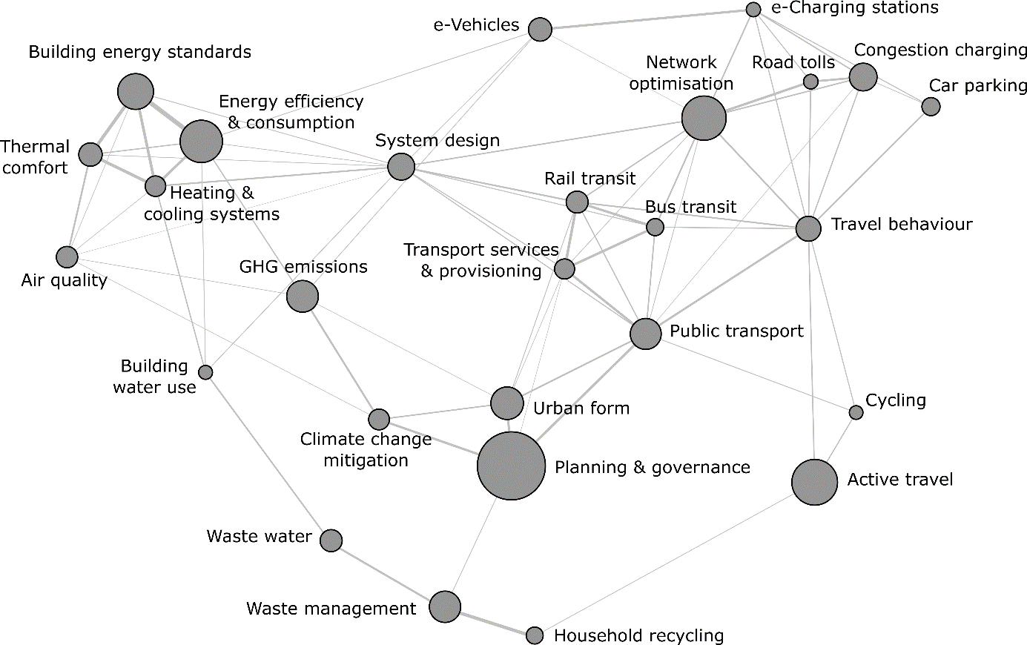

**Figure 3: Correlation structure of urban mitigation topics.** Each node is a topic, scaled by the marginal distribution (see Table 1); each line represents a correlation, based on the co-occurrence of two topics within document abstracts. The highest correlation is 0.3 (between thermal comfort and building energy performance); the lowest is 0.025 (between climate change mitigation and green infrastructure). The visualisation is generated using the force-directed algorithm ForceAtlas2 in Gephi [42].

To what extent is climate change mitigation a prominent discourse in these fields? Table 1 and Figure 3 suggest that it remains rather marginal: papers with climate change mitigation as their main topic tend to focus on macro issues of urban form, GHG (greenhouse gas) emissions accounting in cities, and building interventions (via energy efficiency), but less so on waste management and specific transportation options. In these mitigation-relevant research fields, alternative framings of congestion, access, and public health dominate, instead of a climate-first perspective.

## Epistemic communities in urban mitigation research

What are the epistemic research communities that drive the urban literature? Here we examine this question from the perspective of prevailing citation patterns. Figure 4 shows 8 clusters of documents, grouped by the references they share in common, and labelled by the topics of research they contain. For instance, cluster 1 is a community of research focused on building energy use; it is closely linked to cluster 7, on the waste topics (proximity in this figure denotes a tendency to cite similar literatures). Clusters 4, 5 and 6 identify focused communities of transportation research; on congestion charging, car parking and active travel, respectively.

More interesting are communities of research where multiple topics intersect, such as in cluster 2, which appears to be the main group of papers in which urban climate change mitigation is a key priority. Highly cited papers here include Bulkeley and Bestill’s (2005) study on cities in the multi-level governance of climate change [43], and Pataki et al. (2011), where the role of urban green spaces in reducing GHG emissions is examined [44]. Note again the macro-focus of the topics in this cluster: on planning, urban form, and GHG emissions. While we do see a promising convergence in literatures on buildings, active travel and public transportation around cluster 2, it is nonetheless only indirectly connected to a wider periphery of work on congestion charging, car parking, and waste management.

In contrast to cluster 2, the epistemic community around buildings (cluster 1) offers a more focused discourse: on direct energy demand reduction via standards [45], behaviours [46]and technical interventions [47]. This research is directly relevant to mitigation, although it is firmly framed in terms of households and buildings, not the urban areas in which they are situated.

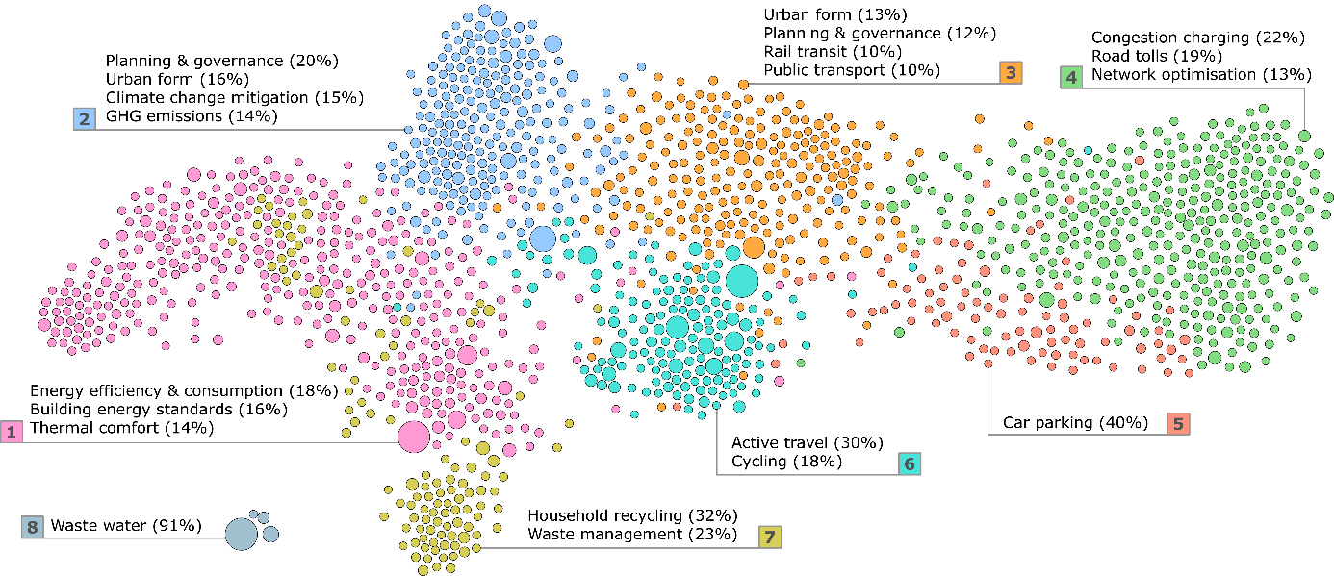

**Figure 4: Bibliographic coupling network of urban mitigation topics.** Each node (circle) represents a publication, scaled by total citations. Proximity between nodes indicates similar citing patterns. To identify epistemic communities, we specify clusters of proximate nodes using a community detection algorithm (displayed as colour), sum all document-topic scores within each cluster (derived from the preceding automated content analysis), then display the topics that exceed 10% of the total topic score in each cluster. For instance, in cluster 7 (coloured in yellow), 32% of the sum of all topic scores are related to “Household Recycling”, and 23% are related to “Waste Management”.

To what extent are assessments of urban mitigation likely to be constrained by this community structure? If we assume IPCC authors are drawn from the mitigation-focused clusters 1 and 2, and they primarily review literature they are familiar with, then certain topics risk being overlooked. Indeed, within the 129 references in AR5 that we match with this set of urban mitigation literature, there is a predominant focus on urban form, GHG emissions accounting, building energy consumption, public transportation, and active travel (Supplementary Materials Fig 2). Topics on parking, waste management, cycling, and road tolls are underrepresented in the report (i.e. those topics that are more distant from cluster 1 and 2).

**Discussion and conclusion**

It is the mandate of the IPCC to provide comprehensive, objective, open and transparent assessments of the available scientific literature on climate change [48]. We have argued elsewhere [16] that it will be increasingly problematic to fulfill this mandate in times of an exponentially growing literature, unless there is real innovation in assessment practices. In recognition of these new challenges and the inclusion of cities as a distinct topic in the 1.5°C SR, we delineate a body of literature on urban climate change mitigation, arguing for a demand-side focus on buildings, transportation, waste management, and urban form. Justifying a literature selection and identifying it through an explicit and reproducible search query is a crucial precondition for any comprehensive scientific assessment, yet commonly neglected in practice. We aim to assist such a process through our analysis in this paper and in the material we provide.

There are different ways in which an urban mitigation search query could have been constructed. For instance, we might have included supply-side options like building-scale electricity generation, or access to health, education and leisure services, which are themselves relevant for patterns of energy consumption. In choosing a more restricted scope, we focus attention on areas of demand-side research that are less well represented in current assessments – and to stimulate discussions on such fundamental questions for the upcoming 1.5°C SR.

How is the literature organized in terms of key objectives for the short, medium and long-term? Our short review points to widely varying timescales in urban mitigation policies, from immediate measures that target behavior change, to longer-term interventions in transportation and building use that ultimately stimulate a structural shift towards low-carbon compact urban forms. Mitigating to 1.5°C would require harnessing all available measures and initiating them with immediacy. It is therefore instructive to examine current trends in urban mitigation research, in terms of prevailing topics and epistemic communities, to uncover the depth to which a full array of options is being considered.

To this end, we apply automated content analysis and bibliographic coupling to digest the large amount of information in this literature and map-out its topic landscape. Our results suggest that mitigation-focused urban studies are so far mainly concerned with urban form and GHG emissions accounting – important topics in their own right, but not fully representative of the broad solution space. A wealth of policy-relevant research risks being overlooked: principally work on congestion, parking charges, and waste management, but also to some extent active travel and public transportation provisioning. These literatures are based in distinct epistemic communities that tend to prioritize non-mitigation, sector-specific issues. By contrast, the buildings literature is already strongly aligned towards energy efficiency, via technical as well as behavioral interventions, but is not yet clearly situated within urban systems. Apparently the topic of urban climate change policies is just emerging, which is not surprising as there are still very few comparable emissions data available at the city scale [9,15].

This broad picture of the research landscape is consistent with our analysis of the AR5, which captured a small fraction of the literature we identify, again with a predominant focus on urban form, emissions accounting, and buildings. While there might be very good reasons for these choices, we argue that systematic mappings of the literature landscape could help make assessment choices transparent and at the same time ensure that none of the major topics are neglected. Although the literature set we obtain is large (9,525 publications), review papers are easily identifiable (totaling 372). In times when primary studies can no longer be comprehensively assessed within the IPCC, it seems key to explicitly prioritize the systematic assessment of these where available. We provide these reviews by topic, as well as the full document list, as a resource in the supplementary material.

Moreover, our research approach can also help identify the most recent trends in the literature post AR5. There is, for example, a fast-growing research cluster around e-mobility with topics on e-vehicles, charging station and parking spaces. As these topics have been comparatively small in the past, IPCC authors may want to give them more consideration in the future. Research on buildings evolves fastest on water use, energy standards and thermal comfort. Overall, urban form is the fastest growing topic post-AR5. More comprehensive data is provided in the SI. We do not suggest here that the fastest growing topics should be the focus of upcoming assessments – urban form has already had due consideration. Instead, topic mapping exercises such as this can provide the empirical foundation for discussions on what may or may not constitute a balanced assessment.

Ideally, the urban mitigation literature would provide a platform for converging multiple streams of research, identifying linkages and complementary policies. For instance, public transit corridors, such as bus rapid transit, placed adjacent to new affordable housing developments would provide residents with an accessible mobility option *before* they have purchased a personal vehicle, potentially inducing preferences and habits favoring public transportation that last for the medium to long term [49]. This suggests an important avenue of future research, towards integrating land-use and transport planning to derive additional mitigation benefits [50–53], instead of focusing on sector specific options only. Mitigating to 1.5°C will require interaction and linkages across multiple urban dimensions – and this is especially true in places with rapidly growing cities.

Finally, in this paper we introduce new methods from computational linguistics to assist research synthesis. The urban mitigation literature, with its broad array of topics, disciplines, and epistemic communities, can benefit from the application of such tools. In this paper we apply these tools to characterize the research landscape, track the integration of different subject areas, and identify research gaps. Other applications could address more fundamental challenges, such as how to synthesize and aggregate knowledge from a rich body of urban case studies – the “gold standard” for investigating causal mechanisms [54,55]. As a starting point, the reference list and topic identification provided could be used to construct a detailed case study database. This and other endeavors that facilitate collaborative knowledge learning will be key to realizing the full potential of cities to implement and deliver climate solutions.

1. Rogelj J, Luderer G, Pietzcker RC, Kriegler E, Schaeffer M, Krey V, Riahi K: **Energy system transformations for limiting end-of-century warming to below 1.5 °C [Internet]**. *Nat. Clim. Chang.* 2015, **5**:519–527.

2. Luderer G, Pietzcker RC, Bertram C, Kriegler E, Meinshausen M, Edenhofer O: **Economic mitigation challenges: how further delay closes the door for achieving climate targets [Internet]**. *Environ. Res. Lett.* 2013, **8**:34033.

3. Clarke L, Jiang K, Akimoto K, Babiker M, Blanford G, Fisher-Vanden K, Hourcade JC, Krey V, Kriegler E, Loschel A, et al.: **Assessing transformation pathways [Internet]**. In *Climate Change 2014: Mitigation of Climate Change. Contribution of Working Group III to the Fifth Assessment Report of the Intergovernmental Panel on Climate Change*. Edited by Edenhofer O, Pichs-Madruga R, Sokona Y, Farahani E, Kadner S, Seyboth A, Adler A, Baum I, Brunner S, Eickemeier P, et al. Cambridge University Press; 2014.

4. IPCC: **Summary for Policymakers**. In *Climate Change 2014: Mitigation of Climate Change. Contribution of Working Group III to the Fifth Assessment Report of the Intergovernmental Panel on Climate Change*. Edited by Edenhofer O, Pichs-Madruga R, Sokona Y, Farahani E, Kadner S, Seyboth K, Adler A, Baum I, Brunner S, Eickemeier P, et al. Cambridge University Press; 2014:1–33.

5. Rogelj J, Popp A, Calvin K V., Luderer G, Emmerling J, Gernaat D, Fujimori S, Strefler J, Hasegawa T, Marangoni G, et al.: **Transition pathways towards limiting climate change below 1.5°C.** *Nat. Clim. Chang.* [date unknown], [no volume].

6. Creutzig F, Agoston P, Minx JC, Canadell JG, Andrew RM, Quéré C Le, Peters GP, Sharifi A, Yamagata Y, Dhakal S: **Urban infrastructure choices structure climate solutions [Internet]**. *Nat. Clim. Chang.* 2016, **6**:1054.

7. Müller DB, Liu G, Løvik AN, Modaresi R, Pauliuk S, Steinhoff FS, Brattebø H: **Carbon Emissions of Infrastructure Development**. *Environ. Sci. Technol.* 2013, doi:10.1021/es402618m.

8. Erickson P, Tempest K: *Keeping cities green: Avoiding carbon lock-in due to urban development [Internet]*. 2015.

9. Karen C. S, Dhakal S, Bigio A, Blanco H, Delgado GC, Dewar D, Huang L, Inaba A, Kansal A, Lwasa S, et al.: **Human Settlements, Infrastructure, and Spatial Planning**. In *Climate Change 2014: Mitigation of Climate Change. Contribution of Working Group III to the Fifth Assessment Report of the Intergovernmental Panel on Climate Change*. . Cambridge University Press; 2014:923–1000.

10. C40 Cities Climate Leadership Group: **C40 Cities [Internet]**. 2017, [no volume].

11. Global Covenant of Mayors: **Global Covenant of Mayors for Climate & Energy [Internet]**. 2017, [no volume].

12. UNEP: *The Emissions Gap Report 2017 [Internet]*. United Nations Environment Program (UNEP); 2017.

13. Rogelj J, den Elzen M, Höhne N, Fransen T, Fekete H, Winkler H, Schaeffer R, Sha F, Riahi K, Meinshausen M: **Paris Agreement climate proposals need a boost to keep warming well below 2 °C [Internet]**. *Nature* 2016, **534**:631–639.

14. Somanthan E, Sterner T, Sugiyama T, Chimanikire D, Dubash NK, Essandoh-Yeddu J, Fifita S, Goulder L, Jaffe A, Labandeira X, et al.: **National and Sub-national Policies and Institutions**. In *Climate Change 2014: Mitigation of Climate Change. Contribution of Working Group III to the Fifth Assessment Report of the Intergovernmental Panel on Climate Change*. Edited by Edenhofer O, Pichs-Madruga R, Sokona Y, Farahani E, Kadner S, Seyboth K, Adler A, Baum I, Brunner S, Eickemeier P, et al. Cambridge University Press; 2014:1141–1206.

15. Grubler A, Bai X, Buettner T, Dhakal S, Fisk D, Ichinose T, Keristead J, Sammer G, Satterthwaite D, Schulz N, et al.: **Urban Energy Systems**. In *Global Energy Assessment - Toward a Sustainable Future*. . International Institute for Applied Systems Analysis and Cambridge University Press; 2012:1307–1400.

16. Minx JC, Callaghan MW, Lamb WF, Garard J, Edenhofer O: **Learning about climate change solutions in the IPCC and beyond**. *Environ. Sci. Policy* 2017, doi:10.1016/j.envsci.2017.05.014.

17. Rosenzweig C, Solecki W, Romero-lankao P, Mehrotra S, Dhakal S, Bowman T, Ibrahim SA: *ARC3.2 Summary for City Leaders*. Columbia University; 2015.

18. Marcotullio PJ, Sarzynski A, Albrecht J, Schulz N, Garcia J: **The geography of global urban greenhouse gas emissions: an exploratory analysis**. *Clim. Change* 2013, doi:10.1007/s10584-013-0977-z.

19. Minx J, Baiocchi G, Wiedmann T, Barrett J, Creutzig F, Feng K, Förster M, Pichler P-P, Weisz H, Hubacek K: **Carbon footprints of cities and other human settlements in the UK [Internet]**. *Environ. Res. Lett.* 2013, **8**:35039.

20. Gurney KR, Romero-Lankao P, Seto KC, Hutyra LR, Duren R, Kennedy C, Grimm NB, Ehleringer JR, Marcotullio P, Hughes S, et al.: **Climate change: Track urban emissions on a human scale**. *Nature* 2015, **525**:179–181.

21. Mattauch L, Ridgway M, Creutzig F: **Happy or liberal? Making sense of behavior in transport policy design**. *Transp. Res. Part D Transp. Environ.* 2016, **45**:64–83.

22. Weinberger R, Goetzke F: **Unpacking preference: How previous experience affects auto ownership in the United States**. *Urban Stud.* 2010, [no volume].

23. Ewing R, Cervero R: **Travel and the Built Environment -- A Meta-Analysis**. *J. Am. Plan. Assoc.* 2010, **76**:265–294.

24. IEA: *Energy technology perspective - Towards sustainable urban energy systems*. 2016.

25. Grubler A, Fisk D: *Energizing Sustainable Cities: Assessing Urban Energy*. Routledge; 2013.

26. Seto K, Dhakal S, Bigio AG, Blanco H, Delgado GC, Dewar D, Huang L, Inaba A, Kansal A, Lwasa S, et al.: **Chapter 12: Human Settlements, Infrastructure, and Spatial Planning**. *Clim. Chang. 2014 Mitig. Clim. Chang. Contrib. Work. Gr. III to Fifth Assess. Rep. Intergov. Panel Clim. Chang.* 2014, [no volume].

27. Creutzig F, Fernandez B, Haberl H, Khosla R, Mulugetta Y, Seto KC: **Beyond Technology: Demand-Side Solutions to Climate Change Mitigation**. *Annu. Rev. Environ. Resour.* 2016, **41**:null.

28. Salon D, Boarnet MG, Handy S, Spears S, Tal G: **How do local actions affect VMT? A critical review of the empirical evidence**. *Transp. Res. Part D Transp. Environ.* 2012, **17**:495–508.

29. Bongardt D, Breithaupt M, Creutzig F: **Beyond the fossil city: Towards low carbon transport and green growth**. In *5th regional environmentally sustainable transport forum in Asia, United Nations Centre for Regional Development, Bangkok, Thailand*. . 2010.

30. Bongardt D, Creutzig F, Hüging H, Sakamoto K, Bakker S, Gota S, Böhler-Baedeker S: *Low-carbon land transport: policy handbook*. Routledge; 2013.

31. Creutzig F: **Evolving Narratives of Low-Carbon Futures in Transportation**. *Transp. Rev.* 2016, **36**:341–360.

32. Ürge-Vorsatz D, Novikova A: **Potentials and costs of carbon dioxide mitigation in the world’s buildings**. *Energy Policy* 2008, **36**:642–661.

33. Lucon O, Ürge-Vorsatz D, Zain Ahmed A, Akbari H, Bertoldi P, Cabeza LF, Eyre N, Gadgil A, Harvey LDD, Jiang Y, et al.: **Buildings**. In *Climate Change 2014: Mitigation of Climate Change. Contribution of Working Group III to the Fifth Assessment Report of the Intergovernmental Panel on Climate Change [Edenhofer, O., R. Pichs-Madruga, Y. Sokona, E. Farahani, S. Kadner, K. Seyboth, A. Adler,*. . 2014.

34. Ürge-Vorsatz D, Eyre N, Graham P, Harvey D, Hertwich E, Jiang Y, Kornevall C, Majumbar M, McMahon JE, Mirasgedis S, et al.: **Energy End-Use: Buildings**. In *Global Energy Assessment - Toward a Sustainable Future*. . Cambridge University Press; 2012:649–760.

35. Cabeza LF, Urge-Vorsatz D, McNeil MA, Barreneche C, Serrano S: **Investigating greenhouse challenge from growing trends of electricity consumption through home appliances in buildings [Internet]**. *Renew. Sustain. Energy Rev.* 2014, **36**:188–193.

36. Bajželj B, Richards KS, Allwood JM, Smith P, Dennis JS, Curmi E, Gilligan CA: **Importance of food-demand management for climate mitigation**. *Nat. Clim. Chang.* 2014, **4**:924–929.

37. Lecocq F, Shalizi Z: **The economics of targeted mitigation in infrastructure**. *Clim. Policy* 2014, **14**:187–208.

38. Fujita M: *Urban Economic Theory*. Cambridge University Press; 1989.

39. Creutzig F: **How fuel prices determine public transport infrastructure, modal shares and urban form**. *Urban Clim.* 2014, **10**:63–76.

40. Creutzig F, Baiocchi G, Bierkandt R, Pichler P-P, Seto KC: **Global typology of urban energy use and potentials for an urbanization mitigation wedge [Internet]**. *Proc. Natl. Acad. Sci.* 2015, doi:10.1073/pnas.1315545112.

41. Lee DD, Seung HS: **Learning the parts of objects by non-negative matrix factorization. [Internet]**. *Nature* 1999, **401**:788–91.

42. Jacomy M, Venturini T, Heymann S, Bastian M: **ForceAtlas2, a continuous graph layout algorithm for handy network visualization designed for the Gephi software**. *PLoS One* 2014, **9**:1–12.

43. Bulkeley H, Betsill MM: **Rethinking sustainable cities: Multilevel governance and the “urban” politics of climate change**. *Env. Polit.* 2005, **14**:42–63.

44. Pataki DE, Carreiro MM, Cherrier J, Grulke NE, Jennings V, Pincetl S, Pouyat R V., Whitlow TH, Zipperer WC: **Coupling biogeochemical cycles in urban environments: Ecosystem services, green solutions, and misconceptions**. *Front. Ecol. Environ.* 2011, **9**:27–36.

45. Newsham GR, Mancini S, Birt BJ: **Do LEED-certified buildings save energy? Yes, but...** *Energy Build.* 2009, **41**:897–905.

46. Abrahamse W, Steg L, Vlek C, Rothengatter T: **A review of intervention studies aimed at household energy conservation**. *J. Environ. Psychol.* 2005, **25**:273–291.

47. Dietz T, Gardner GT, Gilligan J, Stern PC, Vandenbergh MP: **Household actions can provide a behavioral wedge to rapidly reduce US carbon emissions [Internet]**. *Proc. Natl. Acad. Sci.* 2009, **106**:18452–18456.

48. IPCC: **Appendix A: Procedures for the preparation, review, acceptance, adoption, approval and publication of IPCC Reports [Internet]**. In *Principles Governing IPCC Work*. . IPCC; 2013.

49. Cervero R, Murphy S, Ferrell C, Goguts N, Tsai Y-H, Arrington GB, Boroski J, Smith-Heimer J, Golem R, Penninger P, et al.: *TCRP Report 102: Transit-Oriented Development in the United States: Experiences, Challenges, and Prospectes*. Transportation Research Board; 2004.

50. Wegener M: **Overview of land use transport models**. In *Handbook of transport geography and spatial systems*. . Emerald Group Publishing Limited; 2004:127–146.

51. Moeckel R, Nagel K: **Maintaining Mobility in Substantial Urban Growth Futures**. *Transp. Res. Procedia* 2016, **19**:70–80.

52. M. W: **Land-use transport interaction models**. In *Handbook of Regional Science*. . Springer; 2014:741–758.

53. Mitchell G, Hargreaves A, Namdeo A, Echenique M: **Land use, transport, and carbon futures: the impact of spatial form strategies in three UK urban regions**. *Environ. Plan. A* 2011, **43**:2143–2163.

54. Margulies JD, Magliocca NR, Schmill MD, Ellis EC: **Ambiguous geographies: Connecting case study knowledge with global change science**. *Ann. Am. Assoc. Geogr.* 2016, **106**:572–596.

55. Steinberg PF: **Can We Generalize from Case Studies?** *Glob. Environ. Polit.* 2015, **15**:152–175.